Algebra 1: Unit 1, Lesson 10

- Simplify the expression $\frac{\sqrt{243}}{\sqrt{300}}$.
$$\frac{9}{10}$$

- A student is finding an equivalent expression for $\sqrt[3]{1875}.$ Their work is shown.
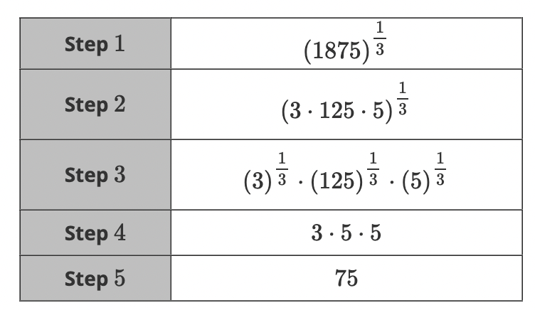
In which step did the student make their mistake?
Step 4

- Simplify the expression $\sqrt{36}∙\sqrt{25}$?

30

